**PRODUCT DESIGN, MANAGEMENT TECHNIQUES AND ENTREPRENEURSHIP PROJECT**

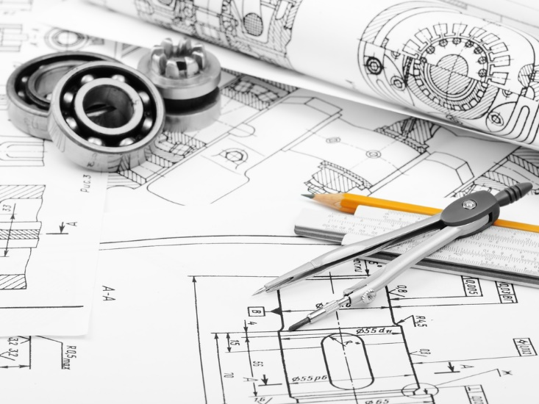

**FALL SEMESTER 2016-2017**



SNAGGER

SNACK WITH SWAGGER!  
  
  
Shubham Parashar(15BCE1318)

Shriansh Srivastava(15BCE1314)

Osho Agyeya(15BCE1326)

Animesh Sen Gupta(15BCE1198)

Har Shobhit Dayal(15BCE1192)

PROJECT SUMMARY

The project is aimed at the design and construction of product “Snagger”. This shall be used at cinema halls and movie theatres for ergonomic placement and accessibility of food items to maximize movie enjoyment while catering to the food needs of the audience by helping them to keep all their food stuff in a single tumbler.

PROJECT DESIGN SPECIFICATION:

BASIC STRUCTURE:

The basic structure of the bucket is inverted frustum (actual dimensions of the product are different from those mentioned in the diagram).

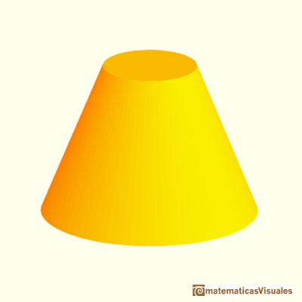

MATERIAL:

* Plastic is an appropriate material since it is easily washable.
* The thickness of the plastic is 3mm.

HEIGHT:

* The proposed height of the structure is 26 cm.

BASE:

* The base of the frustum has a radius of 7.5 cm.
* The base is circular.
* The radius of the cylinder attached to the base is 3.5 cm.

TOP:

* The top of the frustum has a radius of 13 cm.

DIVIDERS:

* The dividers are fixed and have been created at angles of 70 degrees, 70 degrees, 70 degrees and 150 degrees from the vertical.
* The dividers are attached to the inner cylinder at one end and outer cylinder at the other frustum.

BASE OFFSET:

* For three compartments, the base is 6.175 cm above the actual base of the frustum.

ANGLE OF FRUSTUM:

* The angle by which the frustum is slanted on the sides is 8.7692 radians.

PARTITION USAGE:

* There are total 4 partitions.
* The cylinder in the middle is used to store the soft drinks.
* The single compartment which does not have an uplifted base is used for storing popcorns or alternatively whatever food item is supposed to be bought in large quantities.
* The three compartments which have an uplifted base can be used for storing samosas, sandwiches, nachos, chicken lollipops.
* One of the three compartments can be used by the user to simply place his belongings like mobiles, bills and other personal stuff.

SCREENSHOTS FOR SOLIDWORKS FILE:

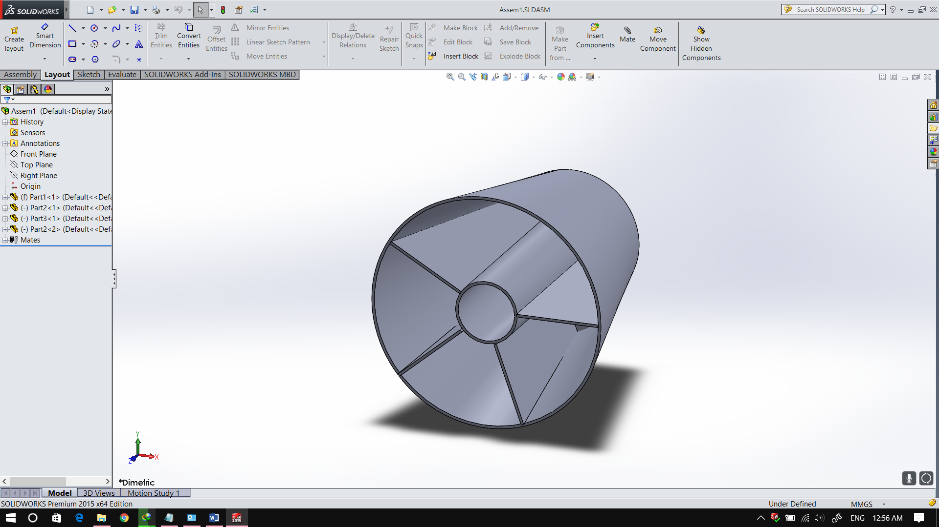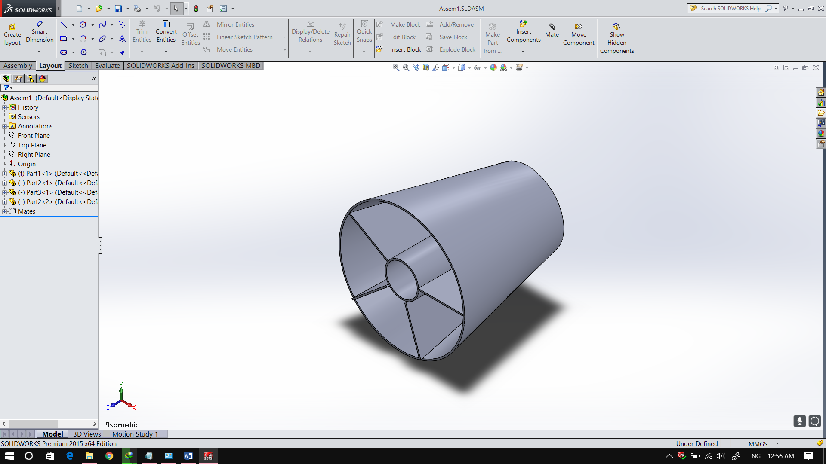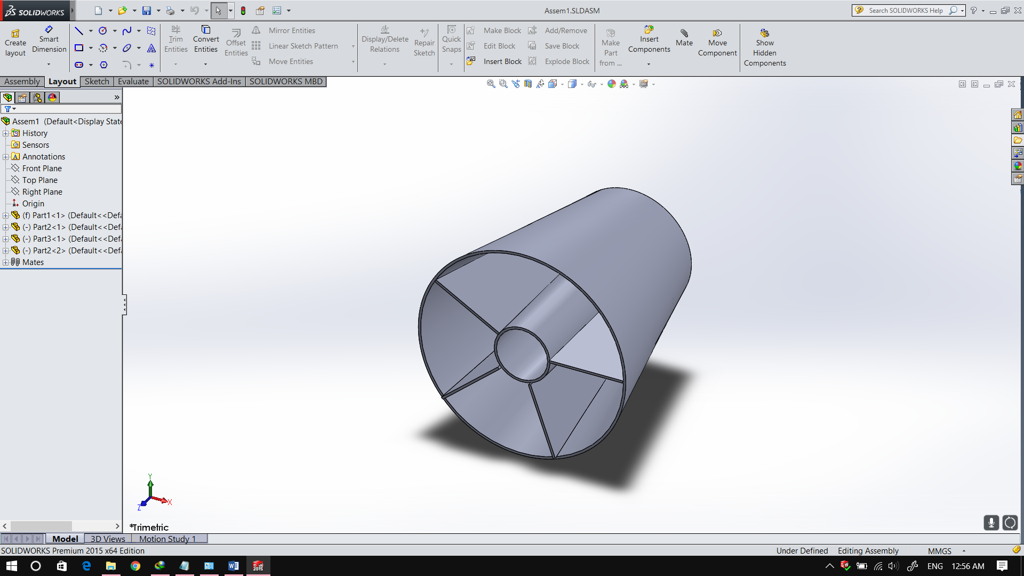

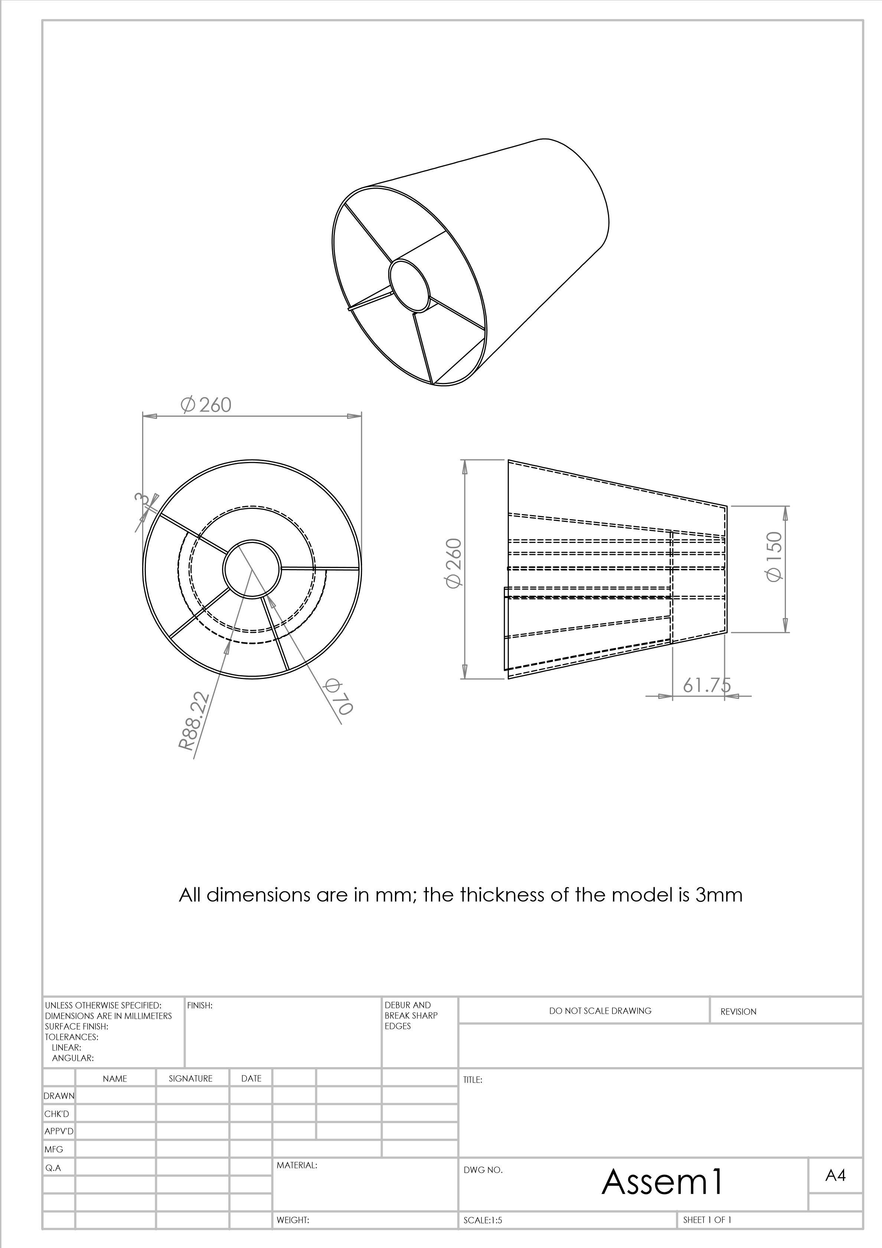PDF GENERATED BY SOLIDWORKS

Assem

WEIGHT:

A3

SHEET 1 OF 1

SCALE:1:5

DWG NO.

TITLE:

REVISION

DO NOT SCALE DRAWING

MATERIAL:

DATE

SIGNATURE

NAME

DEBUR AND

BREAK SHARP

EDGES

FINISH:

UNLESS OTHERWISE SPECIFIED:

DIMENSIONS ARE IN MILLIMETERS

SURFACE FINISH:

TOLERANCES:

LINEAR:

ANGULAR:

Q.A

MFG

APPV'D

CHK'D

DRAWN

SCREENSHOTS FOR WINDOWS BUILDER FILE:

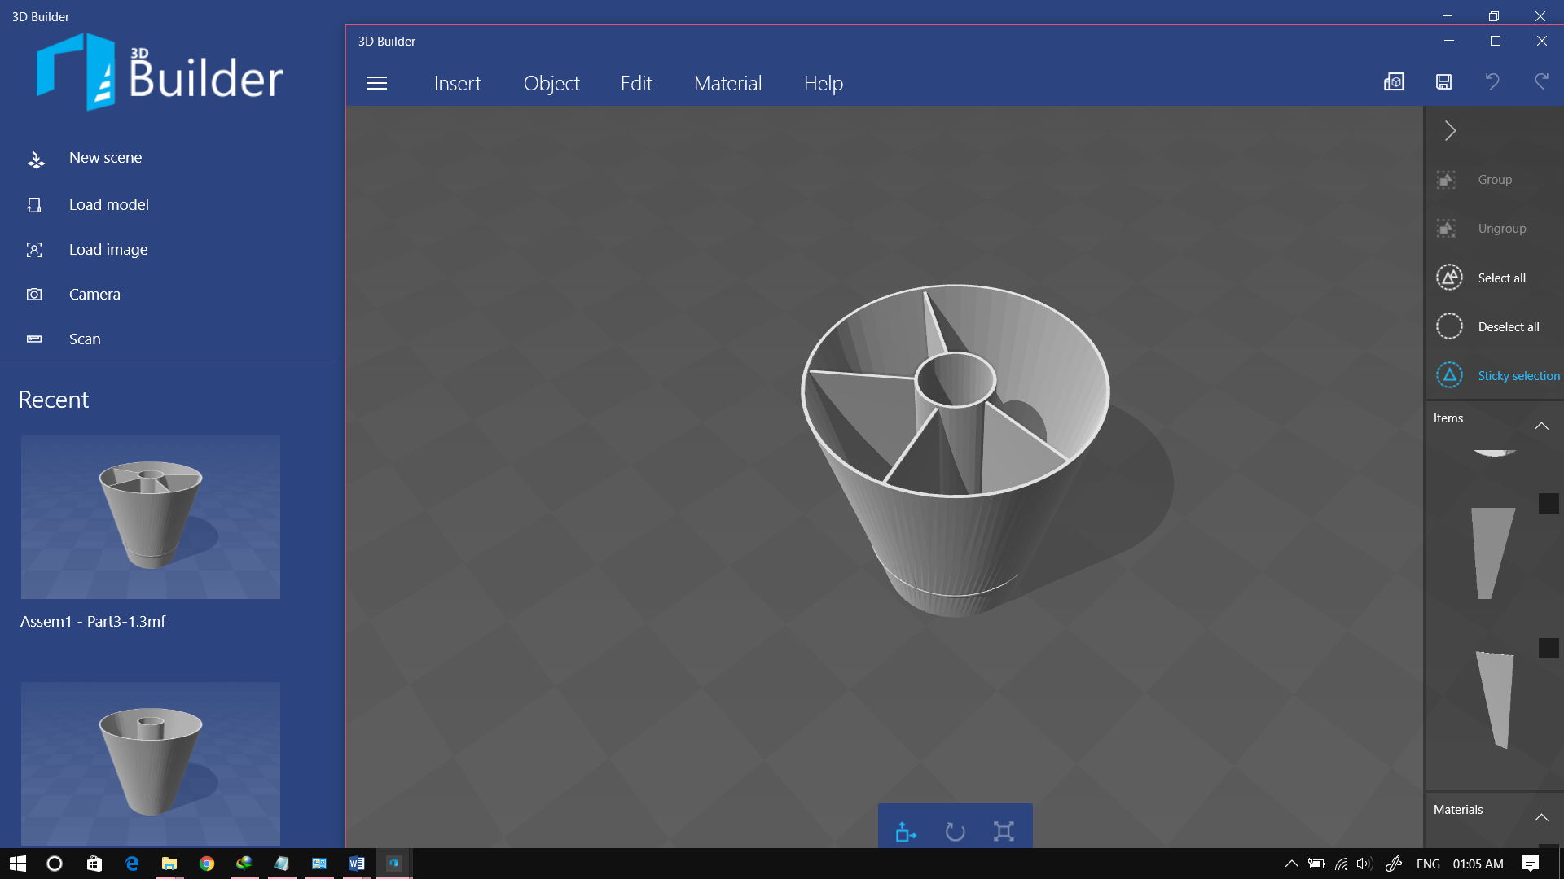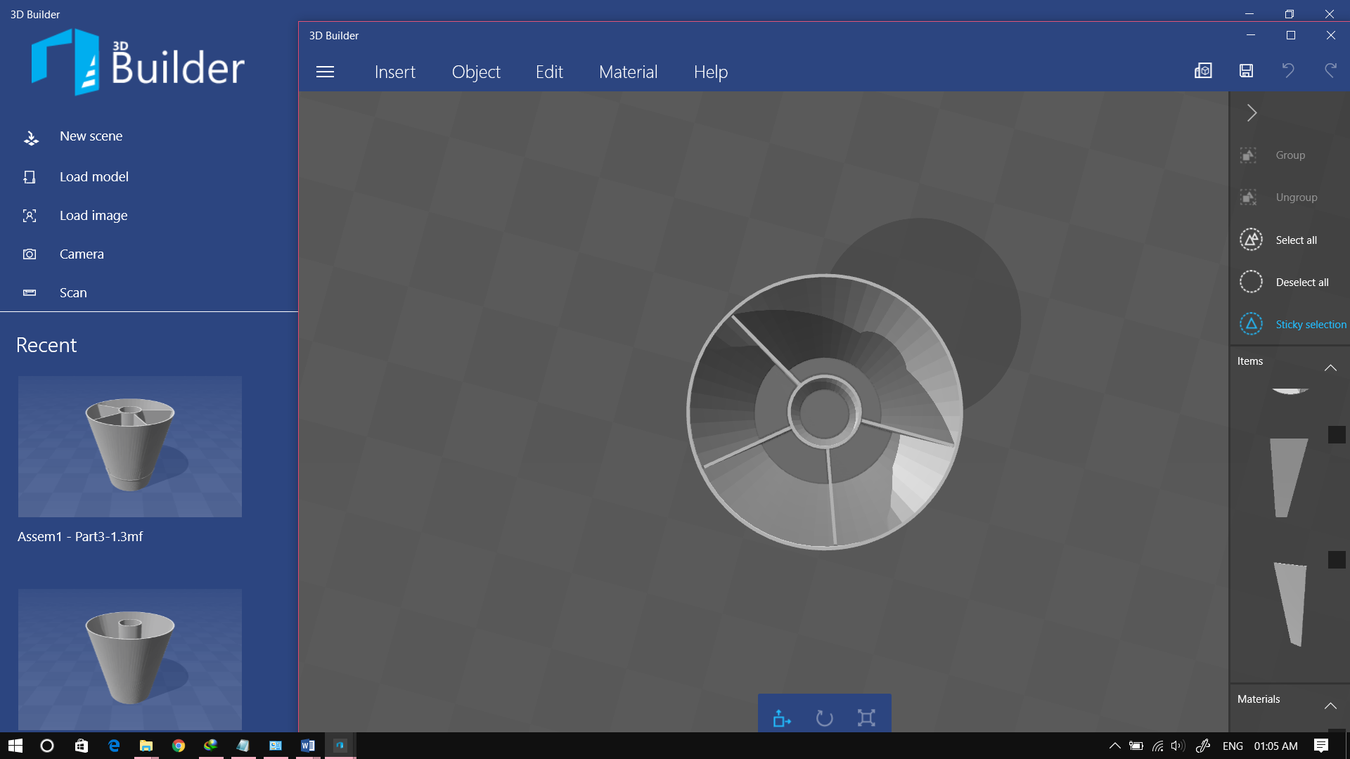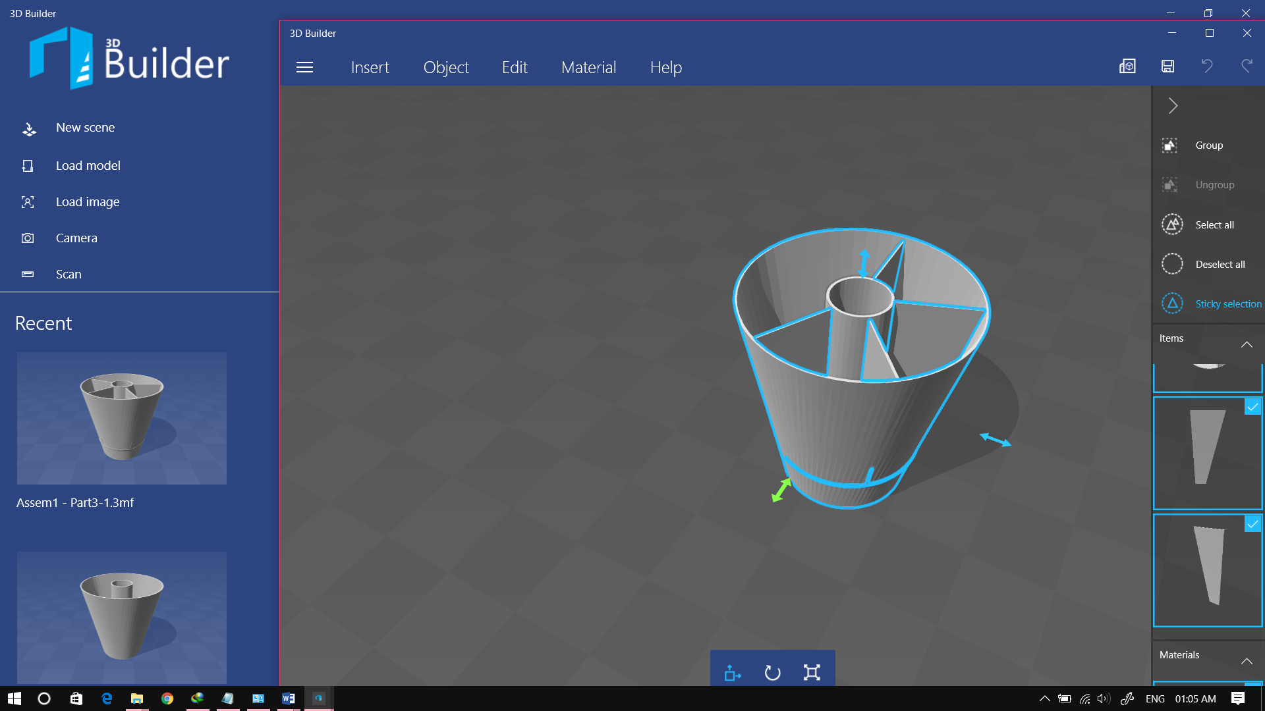

SCREENSHOTS FOR AUTO CAD FILE:

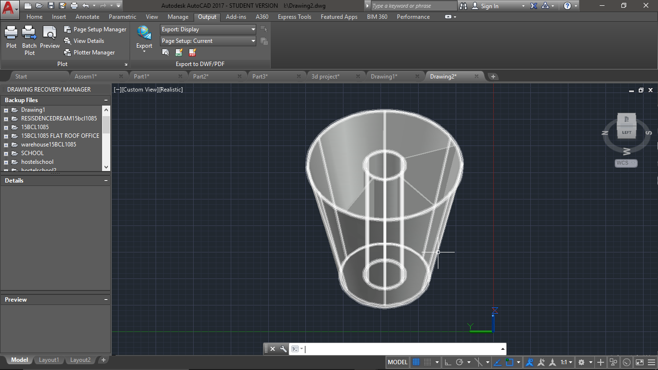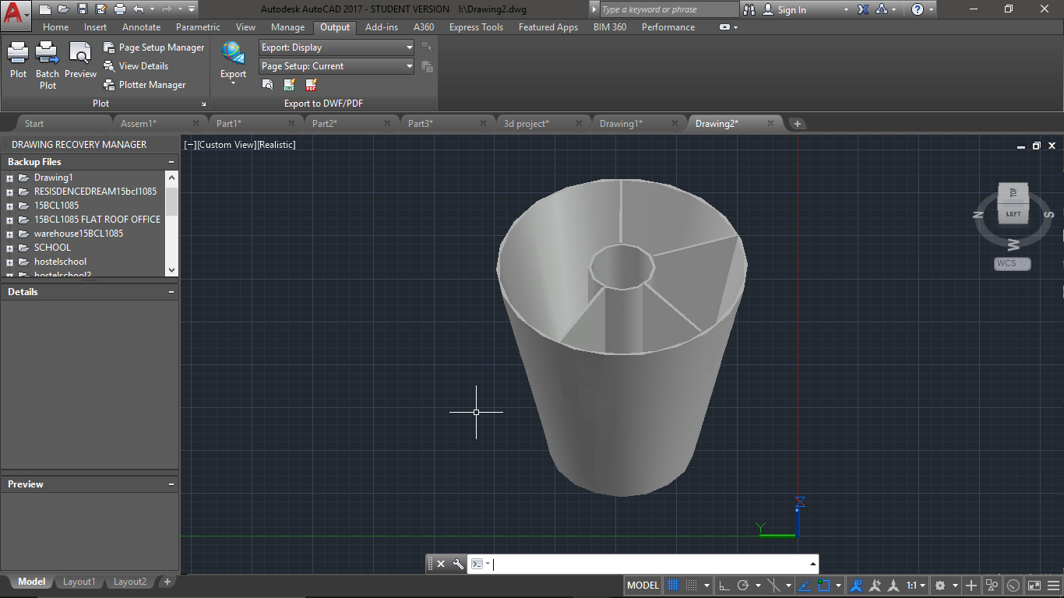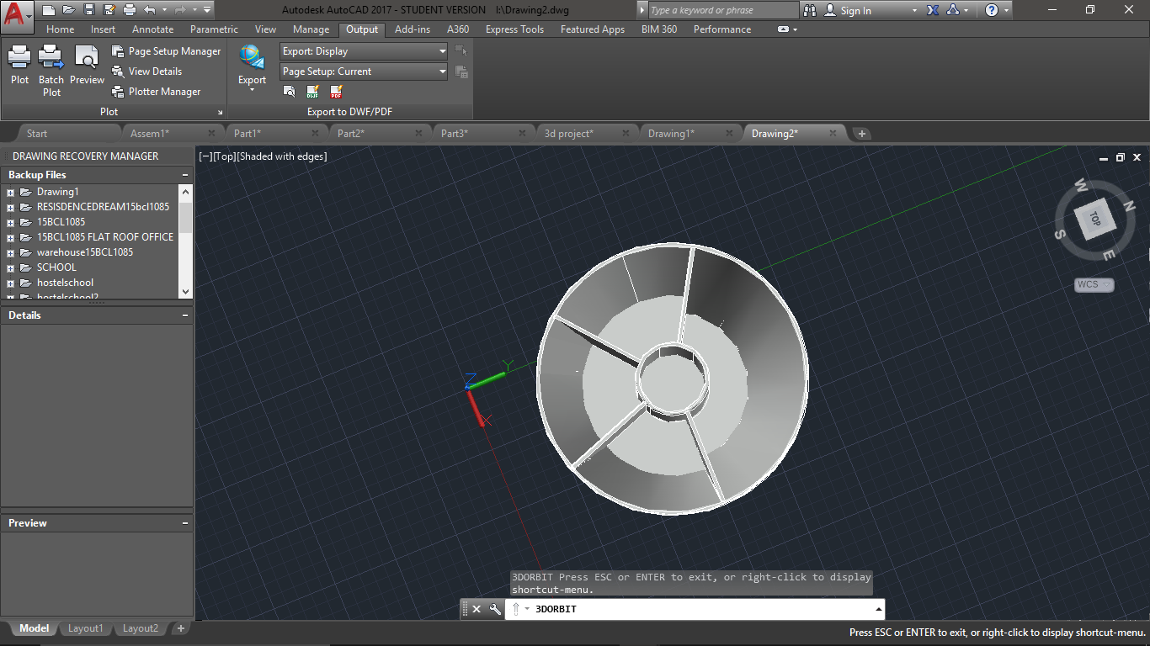

PDF GENERATED BY AUTOCAD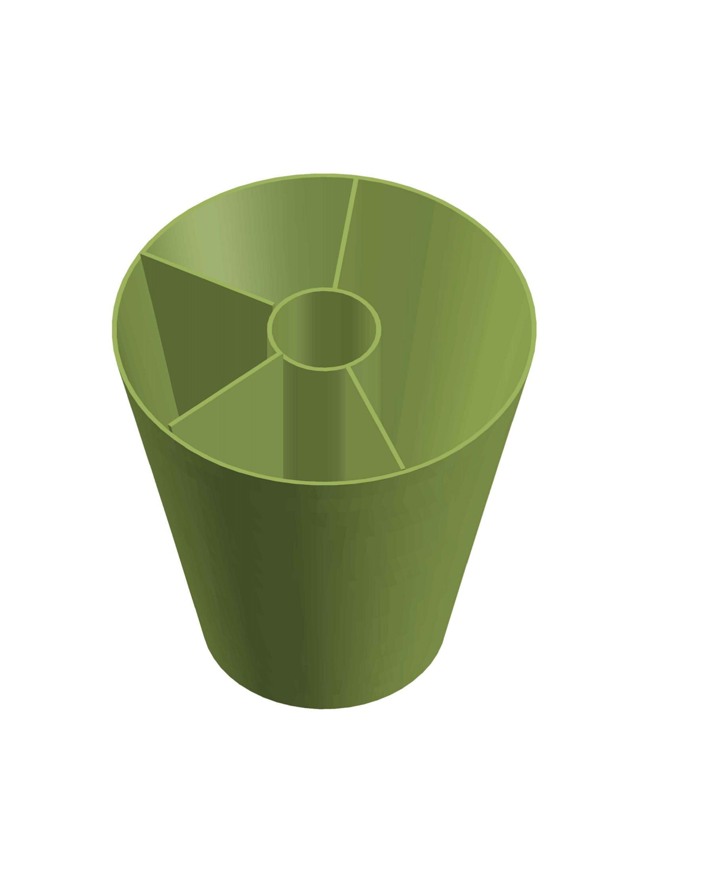

USING MICROSOFT BUILDER FOR 3D PRINTING

